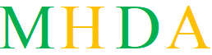 | Referral Form 2026  Support with Housing, Benefits and Non-Regulated Debt Advice  Only Council Tax, water and rent arrears
Complete as much detail as possible so MHDA can understand the client situation and arrange the right support.

Referring Organisation / Individual Information
Name of Referring Organisation / Individual | Self ______________________________________________________
Contact Person | _______________________________________________________
Phone Number | _______________________________________________________
Email | _______________________________________________________
Date of Referral | _______________________________________________________

Client Information
Name | __Shannon Riley _____________________________________________________
Date of Birth | __30/01/1997_____________________________________________________
Address | ___66 Woodland Road Halewood L261XF ____________________________________________________  _______________________________________________________
Phone Number | _07709810229______________________________________________________
Email | _______________________________________________________
NI No. | _______________________________________________________
Children: Name and D.O.B | _______________________________________________________  _______________________________________________________

Employment and Benefits
Are you working? | [ ] Yes [ ] No | Are you on benefits? | [ ] Yes [ ] No
If yes, which benefits? | [ ] UC [ ] PIP [ ] Attendance Allowance |  | [ ] LCWRA [ ] Carers [ ] ESA
Other benefits / details | _______________________________________________________ |  | _______________________________________________________

Support Needed
[ ] Housing | [ ] Benefits | [ X] Non-Regulated Debt Advice
Please select the areas where the client needs support (check all that apply).

Details of Support Needed
Please provide specific details about the support needed in the selected areas:
Housing Support:
____________________________________________________________________________________________
____________________________________________________________________________________________
____________________________________________________________________________________________
Benefits:
____________________________________________________________________________________________
____________________________________________________________________________________________
____________________________________________________________________________________________
Non-Regulated Debt Advice:
____Shannon needs support with council tax. She secured her property on 8th October 2025. And has been paying the premium for unoccupied property. Shannon advised that she has been charged council tax from February 2025. Needs help in finding out if there is anything that can be done. _______________________________________________________________________________________
____________________________________________________________________________________________
____________________________________________________________________________________________

Client Consent
By signing below, the client confirms that they consent to the referral and the sharing of their personal information with MHDA for the purpose of receiving support in the areas specified. The client understands that their information will be managed in accordance with data protection laws.

Client Signature: | ____________________________________ | Date: | ____________________________

Referring Organisation / Individual Declaration
By signing below, the referring organisation/individual confirms that they have obtained the client's consent for this referral and the sharing of their personal information with MHDA.
Referrer Signature: | ____________________________________ | Date: | ____________________________

Additional Information
Please provide any additional information that may help us in supporting the client:
____________________________________________________________________________________________
____________________________________________________________________________________________
____________________________________________________________________________________________
____________________________________________________________________________________________

Contact Information
For any questions or follow-up regarding this referral, please contact:
MHDA
Address: 155 Rowan Drive, Kirkby, Liverpool L32 OSG
Phone: 07749130565 or 07376215961
Email: ann.norris@mhda.co.uk cheryl.roach@mhda.co.uk

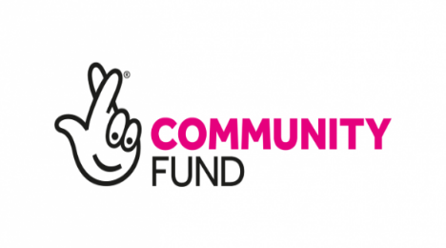 | 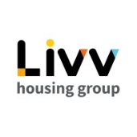 | 

